Module 3 - Guest Analysis Module
This module provides a complete view of guest characteristics, booking behaviors, nationalities, spending profile, and booking channels so the hotel can understand who their customers are and how they behave.
1. Guest Types – Business, Corporate, Family, Solo
Guests are grouped by purpose of travel:
- Business
- Corporate
- Family
- Solo
Each segment behaves differently in terms of duration, spending, and booking patterns, which directly affects revenue and occupancy strategies.
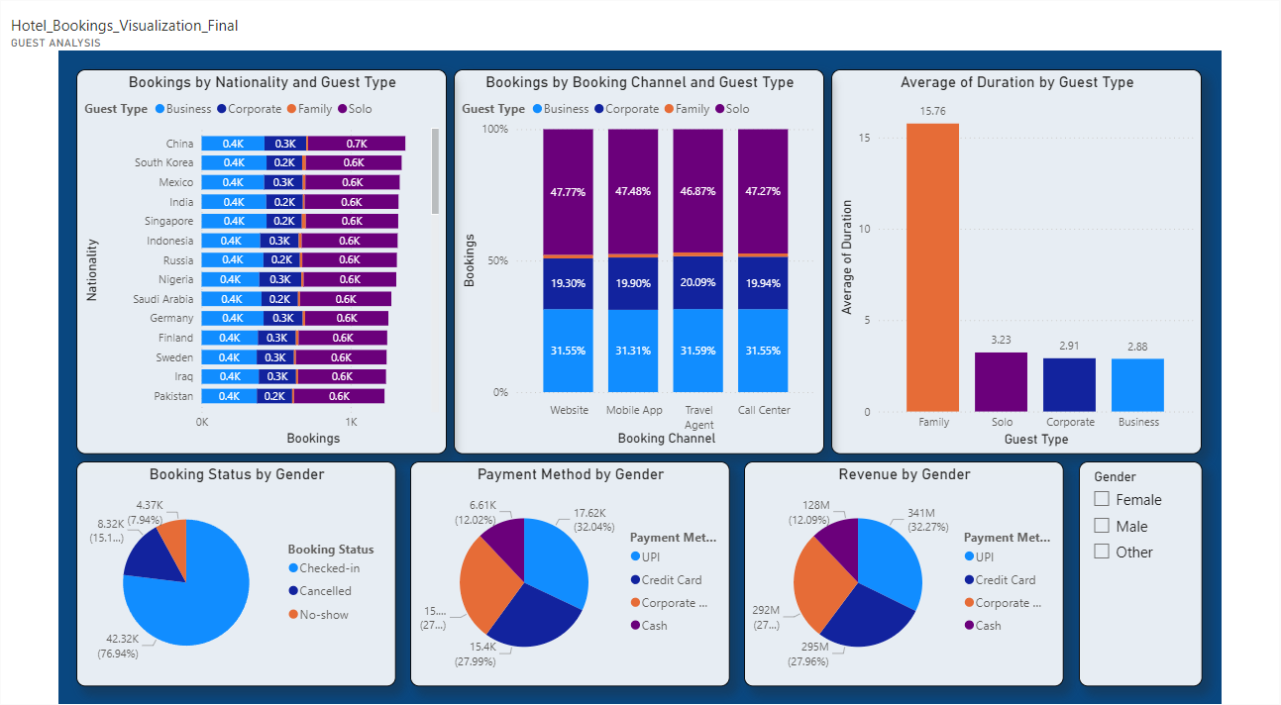
2. Visuals – Nationality, Booking Source, Duration
Nationality
Shows where guests come from and which countries contribute the most volume.

Booking Channels
Website, OTA, Travel agents, Mobile app etc.—helps identify which channel brings which type of guest.
Duration
Bar chart shows average length of stay:
- Family stays much longer
- Solo and Corporate have shorter visits
- Useful for long-stay packages vs business-day pricing.
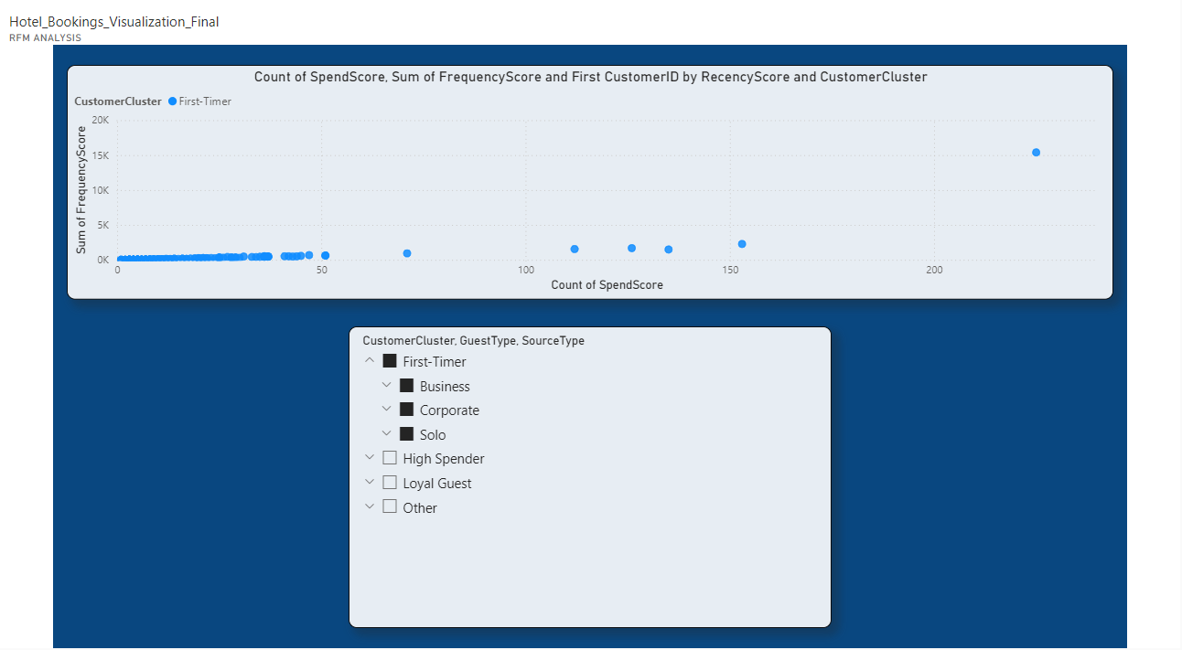
3. Customer Clusters – First-timers, Loyal, High Spenders
RFM-based segmentation highlights:
- First-Timer guests
- Loyal repeat customers
- High-Spend customers
Map visualization and scatter plots locate segments geographically and financially.
This helps discover profitable markets and loyalty drivers.
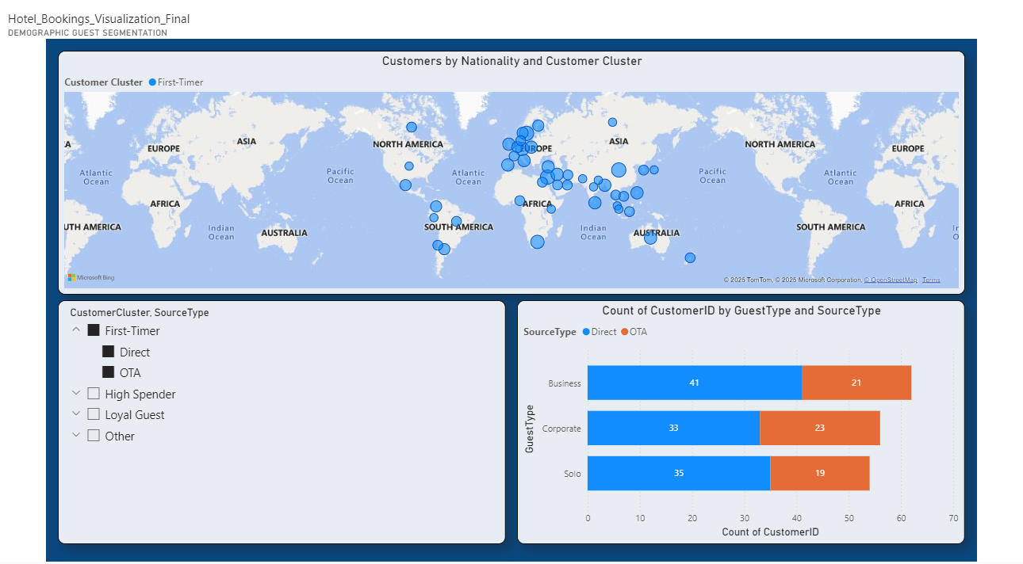
4. Impact – Targeted Offers & Personalization
This segmentation allows:
✔ tailored marketing
✔ customised promotions
✔ loyalty offers
✔ channel-specific pricing
✔ international targeting
✔ family-focused packages
Overall, the hotel can design personalised offers for each guest segment, improving booking conversion, guest retention, and revenue.

